Using watson visual recognition

A HANDS-ON LAB TO TRAIN A VISUAL RECOGNITION MODEL AND IDENTIFY IMAGES IN A CODE-FREE ENVIRONMENT



IBM

Erika Bratschun and Erica Reuter

Notices and Disclaimers

© Copyright IBM Corporation 2017.

The information contained in these materials is provided for informational purposes only, and is provided AS IS without warranty of any kind, express or implied. IBM shall not be responsible for any damages arising out of the use of, or otherwise related to, these materials. Nothing contained in these materials is intended to, nor shall have the effect of, creating any warranties or representations from IBM or its suppliers or licensors, or altering the terms and conditions of the applicable license agreement governing the use of IBM software. References in these materials to IBM products, programs, or services do not imply that they will be available in all countries in which IBM operates. This information is based on current IBM product plans and strategy, which are subject to change by IBM without notice. Product release dates and/or capabilities referenced in these materials may change at any time at IBM’s sole discretion based on market opportunities or other factors, and are not intended to be a commitment to future product or feature availability in any way.

This document is current as of the initial date of publication and may be changed by IBM at any time. Not all offerings are available in every country in which IBM operates.

IBM, the IBM logo and ibm.com are trademarks or registered trademarks of International Business Machines Corporation in the United States, other countries, or both. If these and other IBM trademarked terms are marked on their first occurrence in this information with a trademark symbol (® or ™), these symbols indicate U.S. registered or common law trademarks owned by IBM at the time this information was published. Such trademarks may also be registered or common law trademarks in other countries. A current list of IBM trademarks is available on the Web at “Copyright and trademark information” at ibm.com/legal/copytrade.shtml

Other company, product and service names may be trademarks or service marks of others

Table of Contents

Using Watson Visual Recognition to Compare Mascots and People 3

Prerequisites 4

Purpose of this Lab 4

Part 1: IBM Cloud 5

Part 2: Launching a Service using IBM Cloud 7

Part 3: Launching a Watson Visual Recognition 12

Part 4: Testing the Model 18

Conclusion 22

**Using Watson Visual Recognition to Compare Mascots and People**

# 

# Prerequisites

Signed up for an IBM ID Through IBM Watson Studio free trial at:

<http://bit.ly/wplwatsonstudio>

Click sign-up for a free trial and follow the steps on the page. You will need to confirm your account via an email that is sent and then login to your account once it is verified.

# Purpose of this Lab

The purpose of this lab is to analyze pictures using Watson Visual Recognition.

By the end of this lab, you will be familiar with the following:

* Navigating IBM Cloud Platform
* Launching Services from IBM Cloud
* Using Watson Visual Recognition (including training a model)

# Part 1: IBM Cloud

Log into IBM Cloud at <https://console.bluemix.net/dashboard/apps/>

If this is the first time you are using IBM Cloud (formerly Bluemix), an introduction window will appear, feel free to read it. Otherwise, click through.

Click “Next”, Click “Finish”.

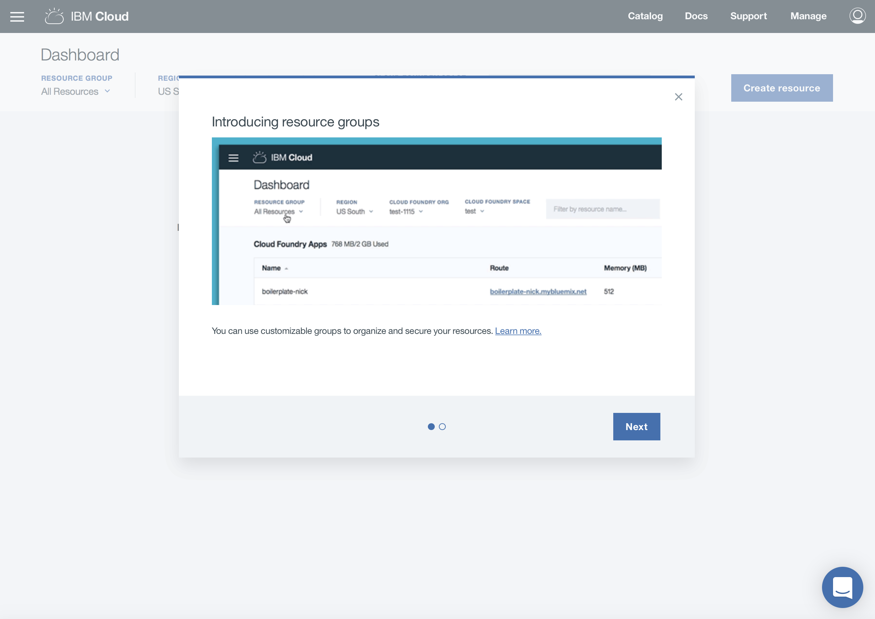

We are now looking at the IBM Cloud Dashboard.

Click on the “Catalog” button found in the upper right-hand corner of the screen

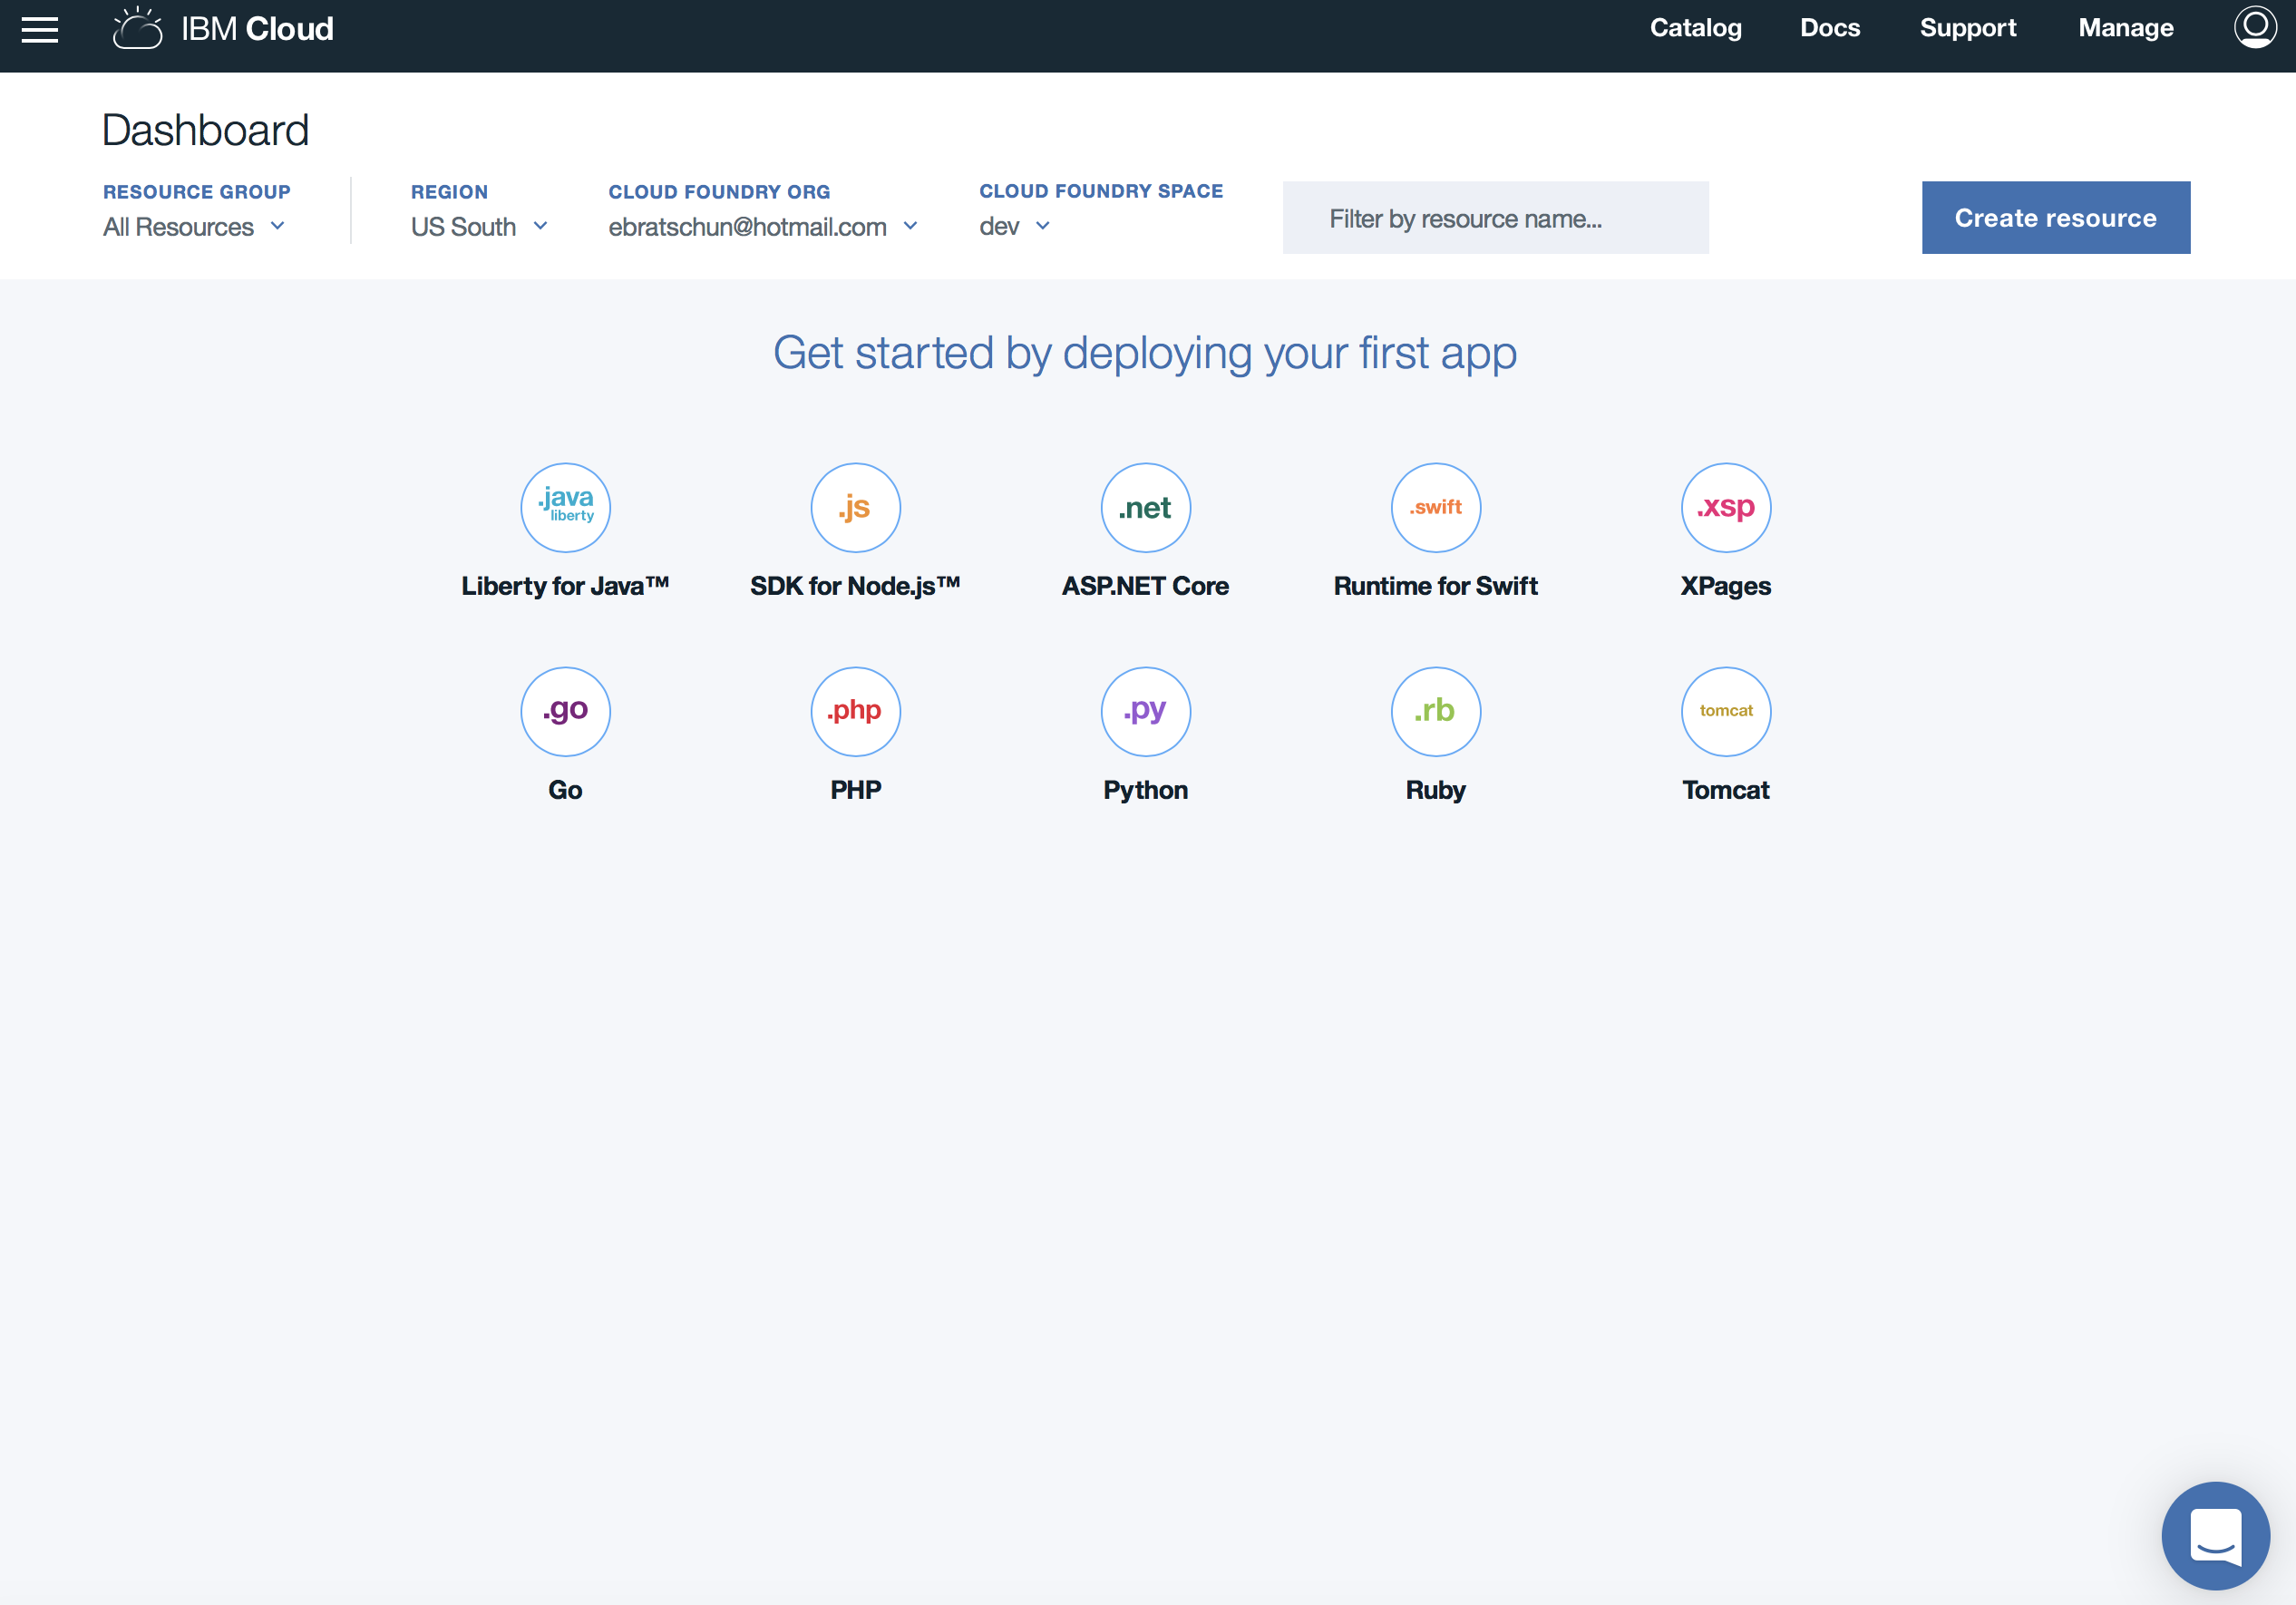

The Catalog is a compilation of the services offered on the IBM Cloud.

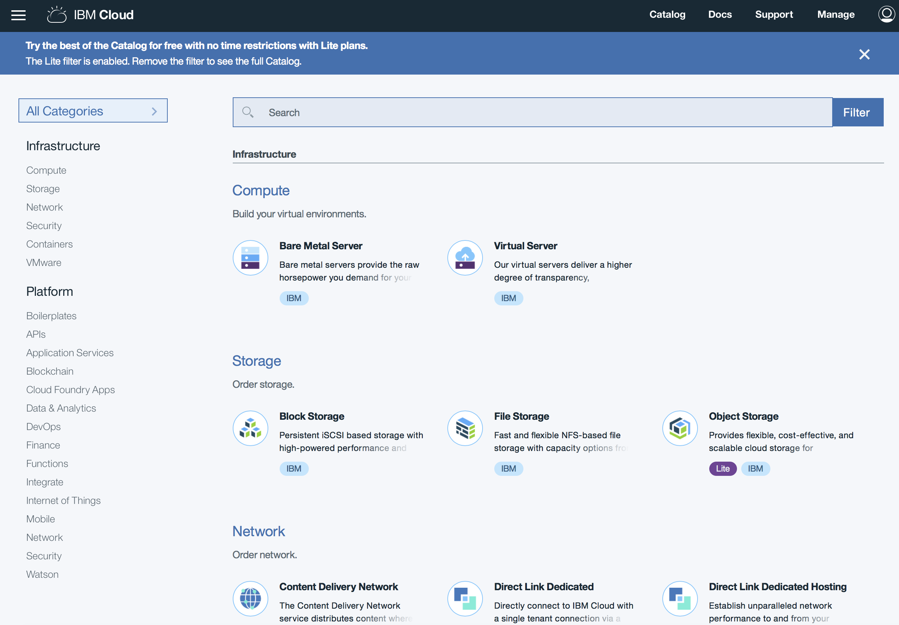

IBM Cloud supports both IBM products and services, as well as third-party. They are indicated by the small ovals below each service description.

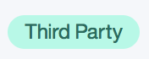

# Part 2: Launching a Service using IBM Cloud

Let’s create our own service.

Type into the search bar: “Visual Recognition” .

Alternative way: In the Categories sections, select Watson, Visual Recognition

Click on “Visual Recognition”.

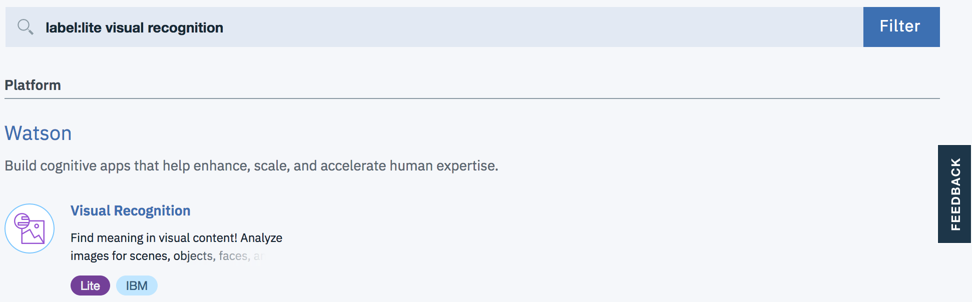

Type a Service name of your choice. This will be added to a list of your deployed services, so it is helpful to use a descriptive title. (Ex. Visual Recognition Lab)

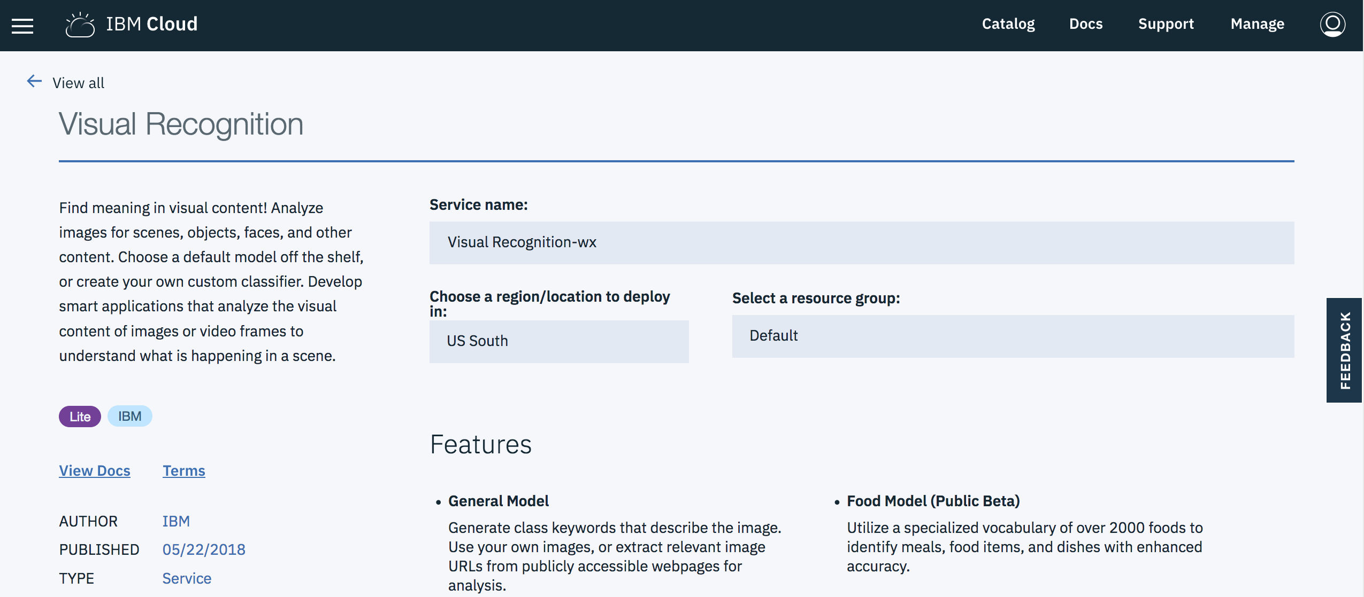

The “Free” plan is selected by default.

Select “Create” to deploy the Visual Recognition Service.

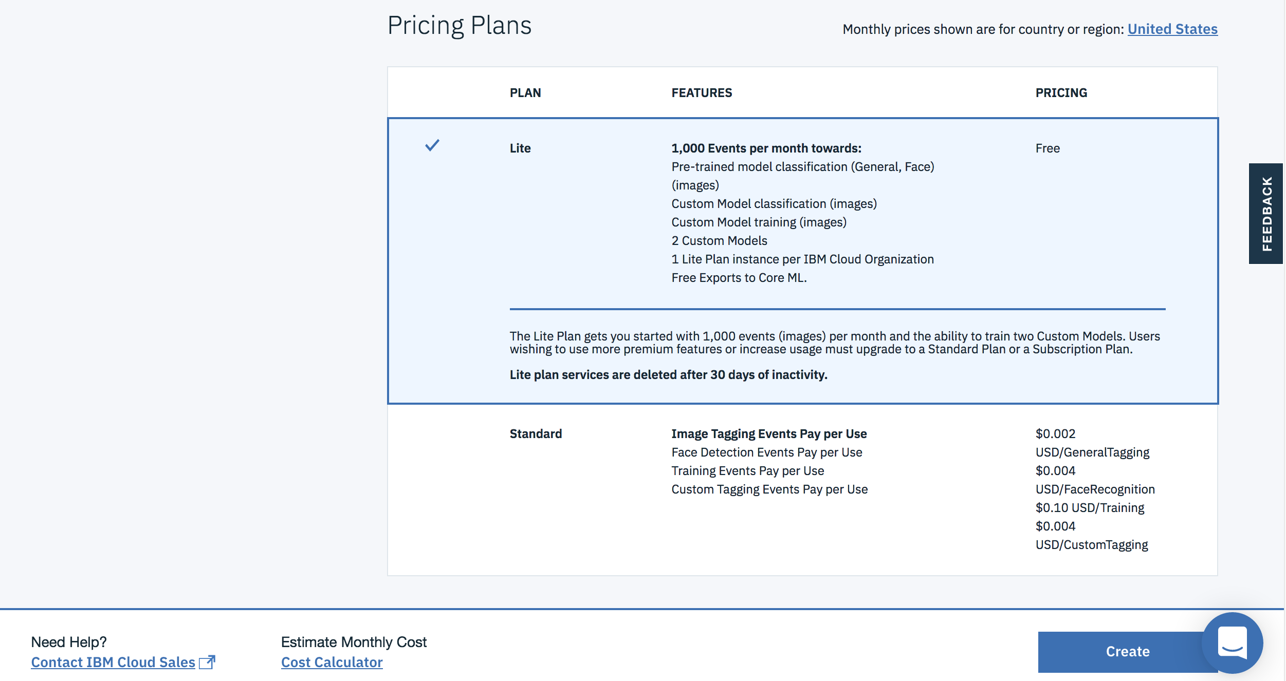

This page indicated that the service had been created.

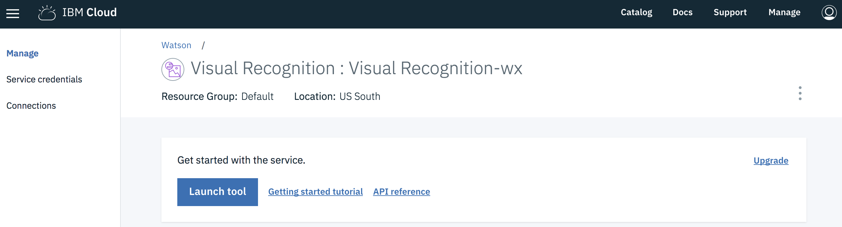

# Part 3: Launching a Watson Visual Recognition

Launch the service by clicking on “Launch Tool”



We are now in the Visual Recognition Tool. There are already some pre-trained classifiers in the tool. Feel free to explore the pre-trained models by clicking on Test next to them.

For the purposes of this workshop, we want to create our own.

Select “Create Model”.

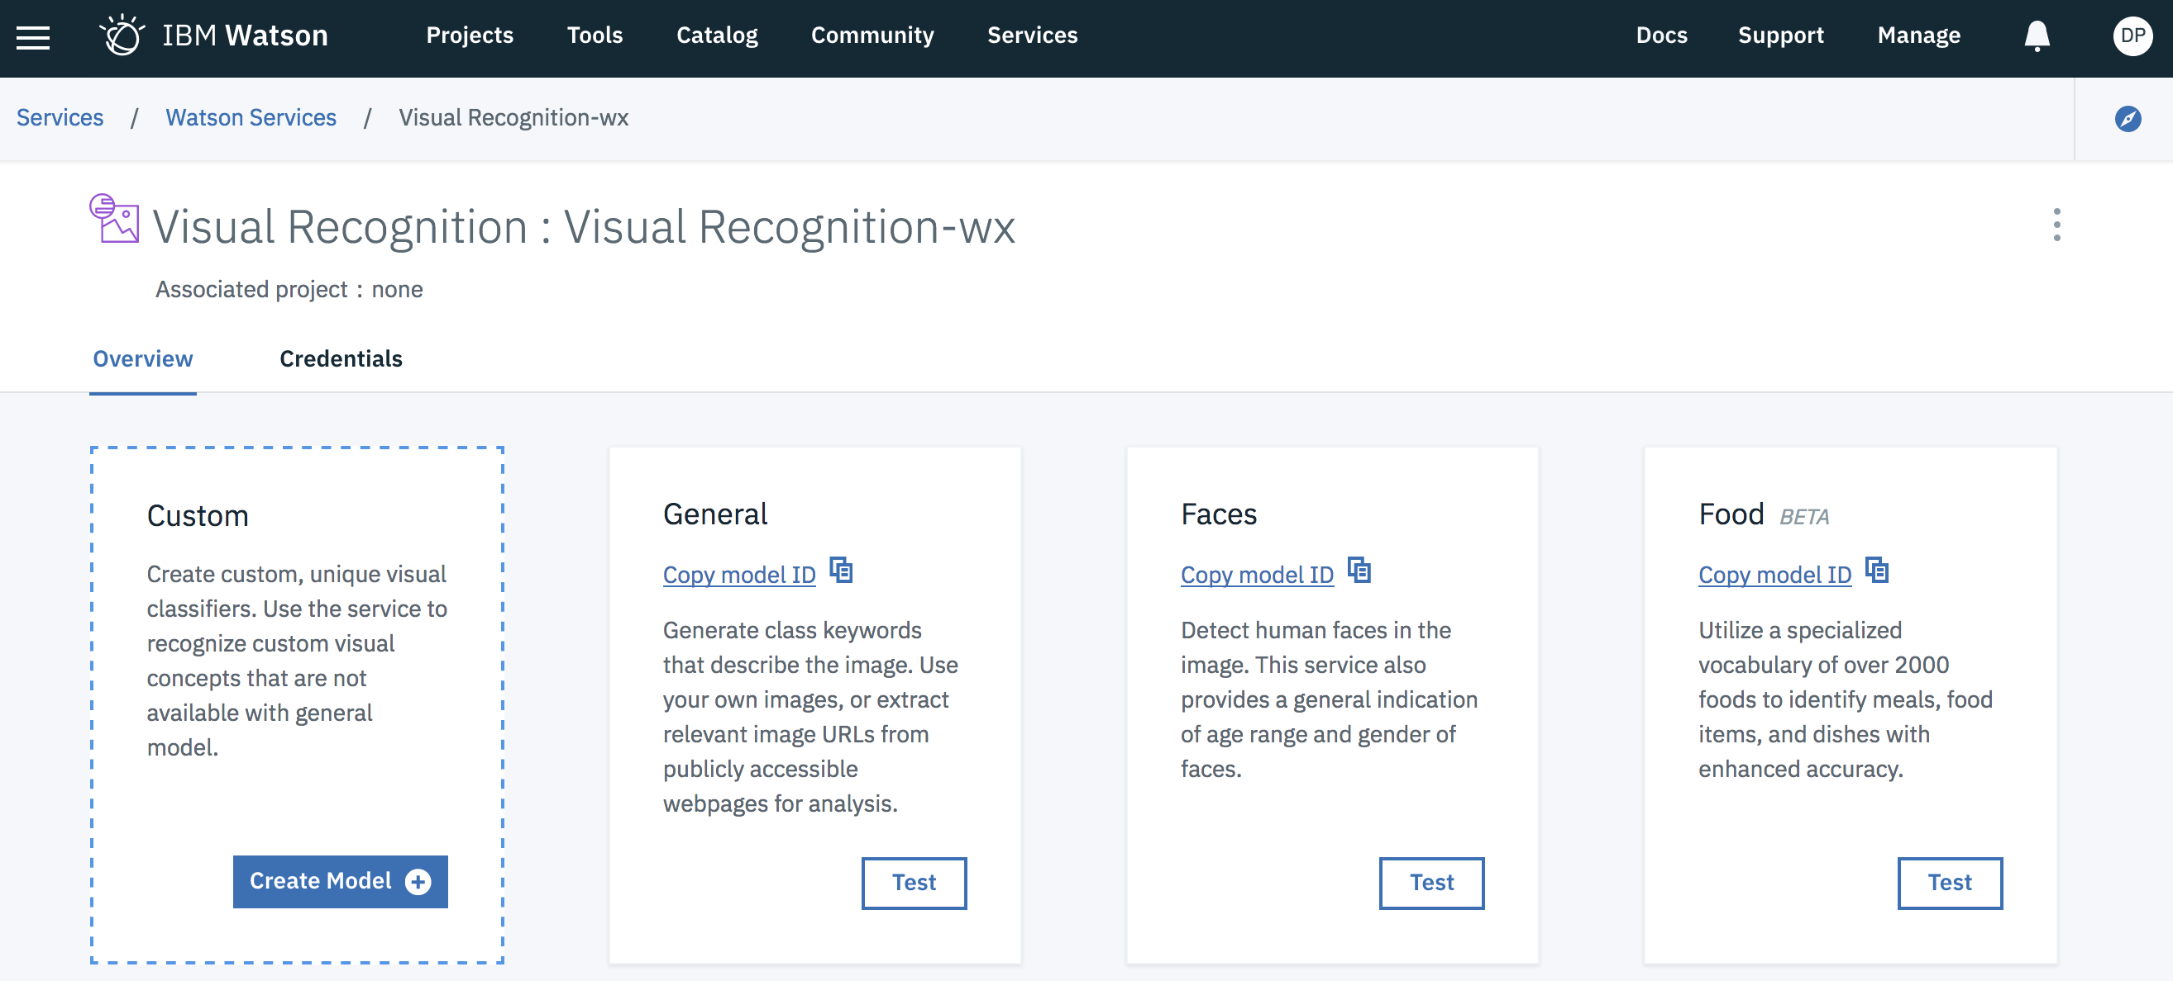

You will be asked to create a new project. Use something meaningful for the project name such as “Visual Recognition Workshop”. If you do not currently have object storage configured, follow the prompts under Storage to create a new object storage instance.

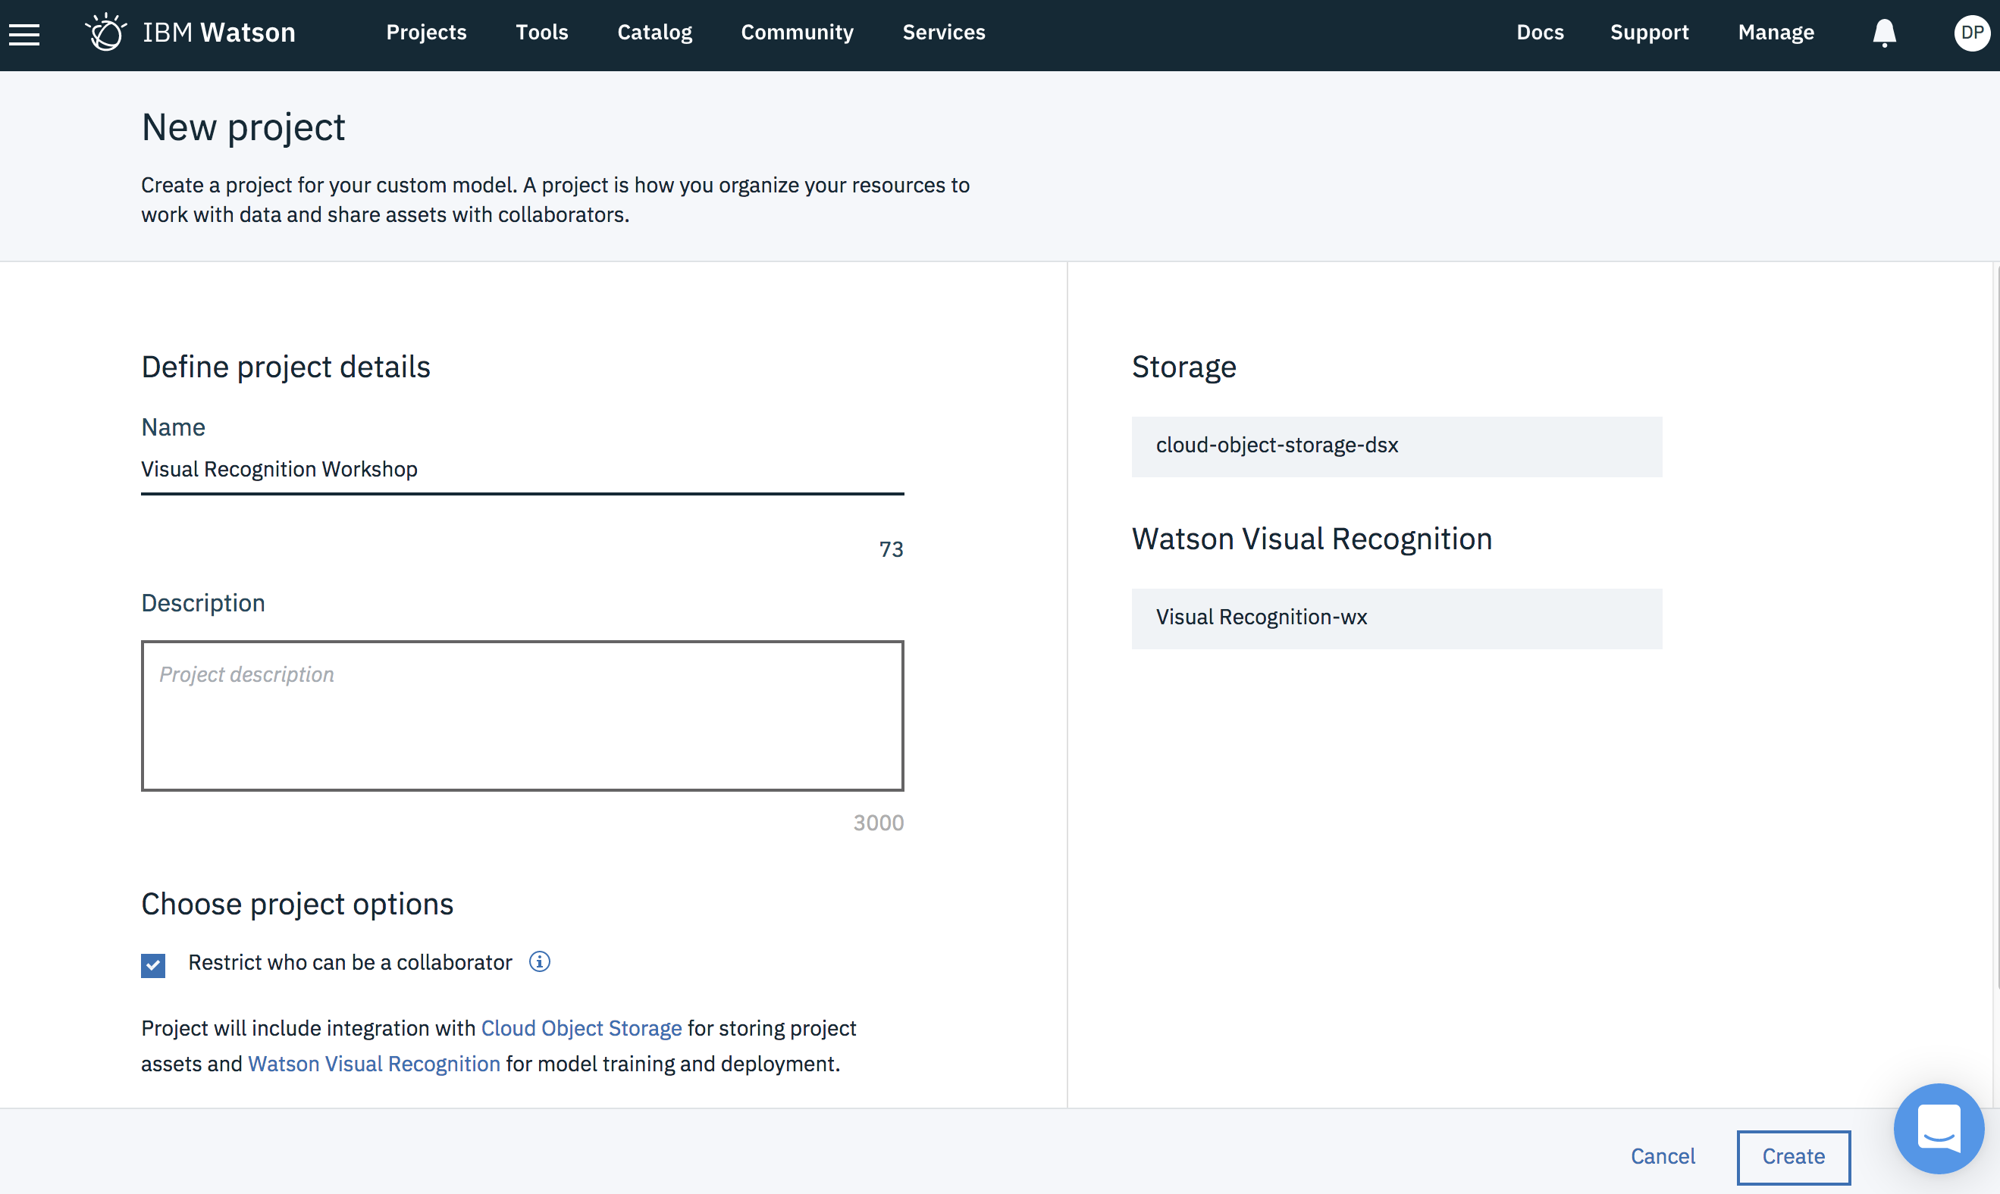

Click “Create”.

*For the purpose of this lab, we will be training the tool with pictures of humans and pictures of mascots.*

Once the Default Custom Model screen appears, click the pencil icon and rename the model to “People and Mascots”.

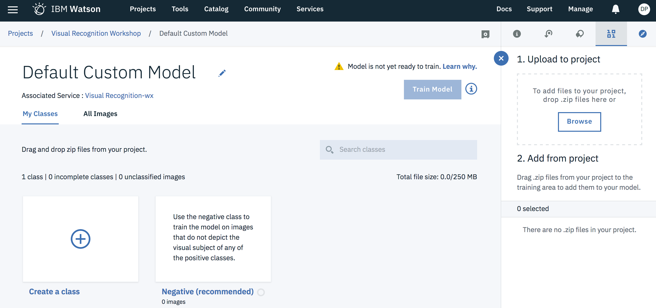

Download Mascots.zip and People.zip from the following GitHub page

<https://github.com/AnalyticsDS/Wolfpack-Technical-Event-Content/tree/master/AI%20and%20Data%20Science/Deep%20Learning/Watson%20Visual%20Recognition>

Now we need to get the zip files into our project. One way to do this is by clicking and dragging the zip files into the “Upload to project box”. Alternatively, the browse button can be used to manually locate the files.

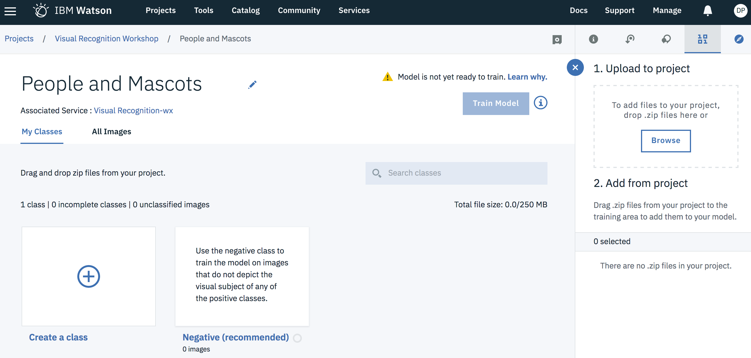

This loads the zip files into object storage and they are saved within the project. Next place a checkbox next to each zip file and click “Add to model”.

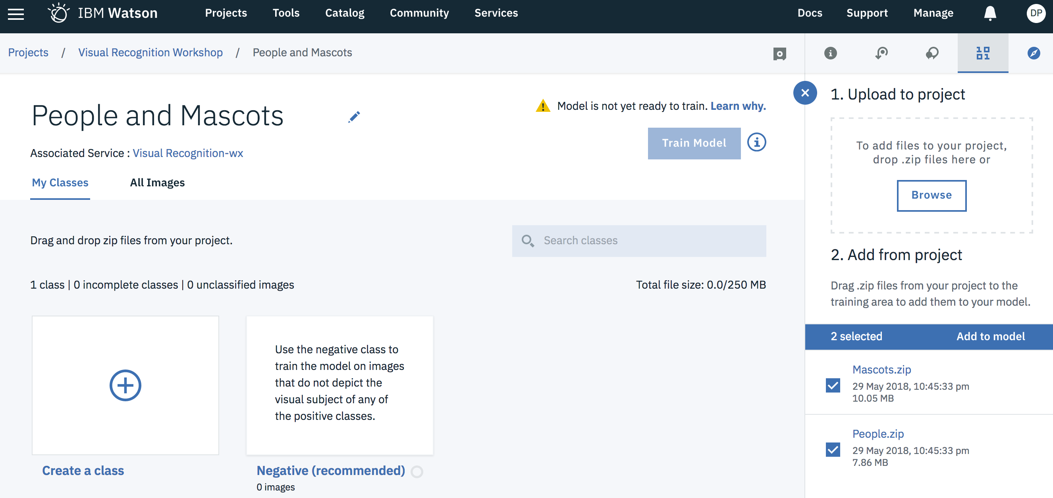

This creates two new classes named Mascots and People.

Select “Train Model”.

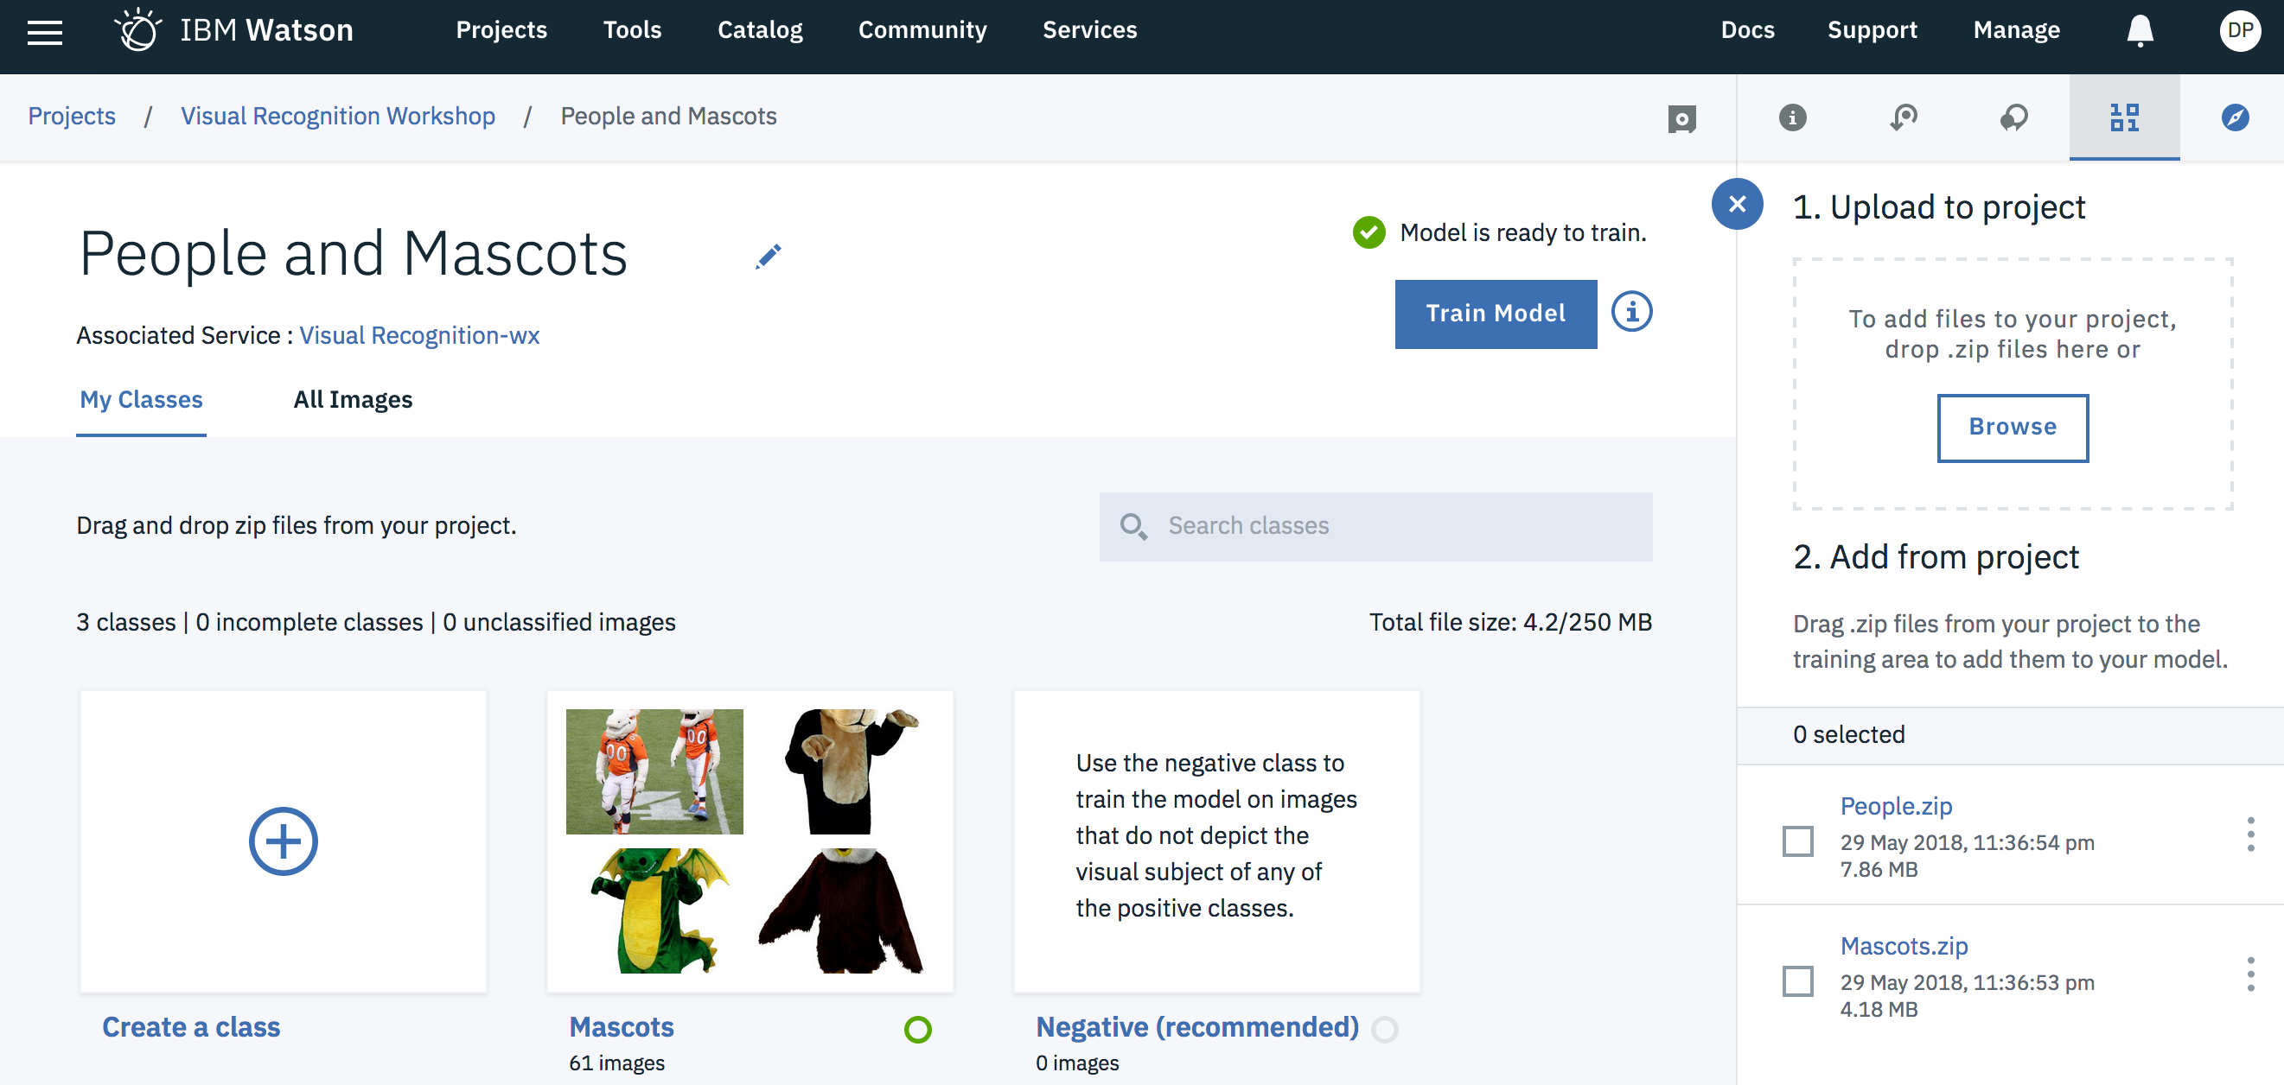

After you select “Train Model”, the “Train Model” button will say “Training” with a spinning icon next to it to indicate that the request is being processed. The process can take several minutes.



Once complete, a “Training Successful” message will appear. Click the “Here” hyperlink in the “Training successful” message.



This opens up the overview page which gives some background of the model such as how many images it was trained on, the number of classes and when it was created. Click the “Test” tab.

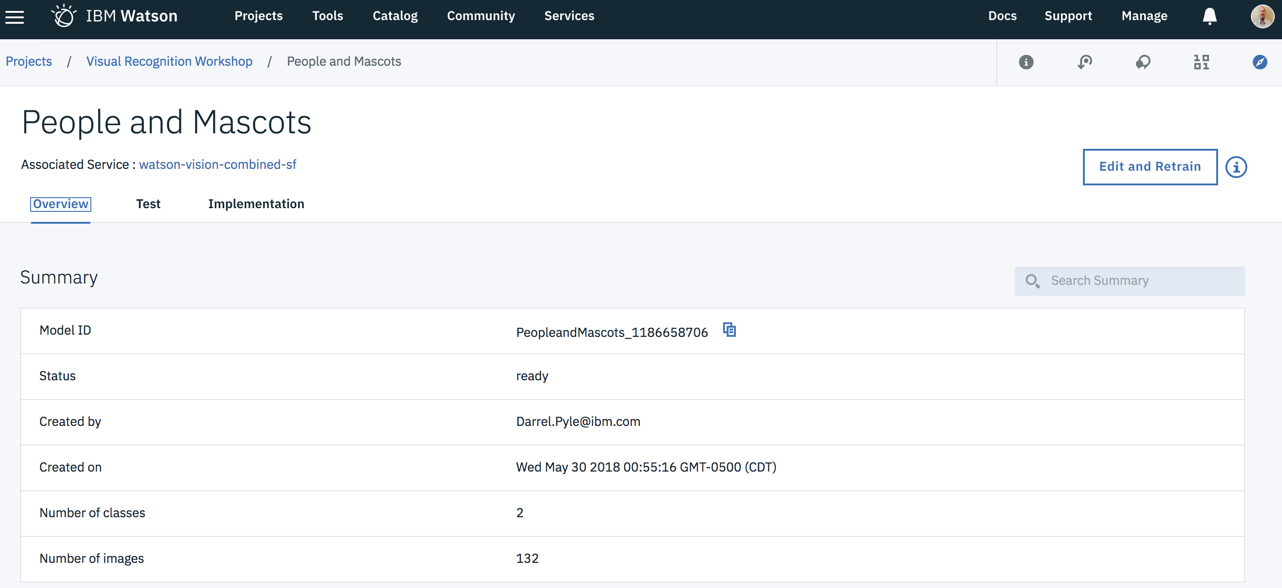

Download and save HumanTest.jpeg and MascotTest.jpeg from the following GitHub page:

<https://github.com/AnalyticsDS/Wolfpack-Technical-Event-Content/tree/master/AI%20and%20Data%20Science/Deep%20Learning/Watson%20Visual%20Recognition>

Testing the model can be completed by dragging and dropping images into the test drop zone.

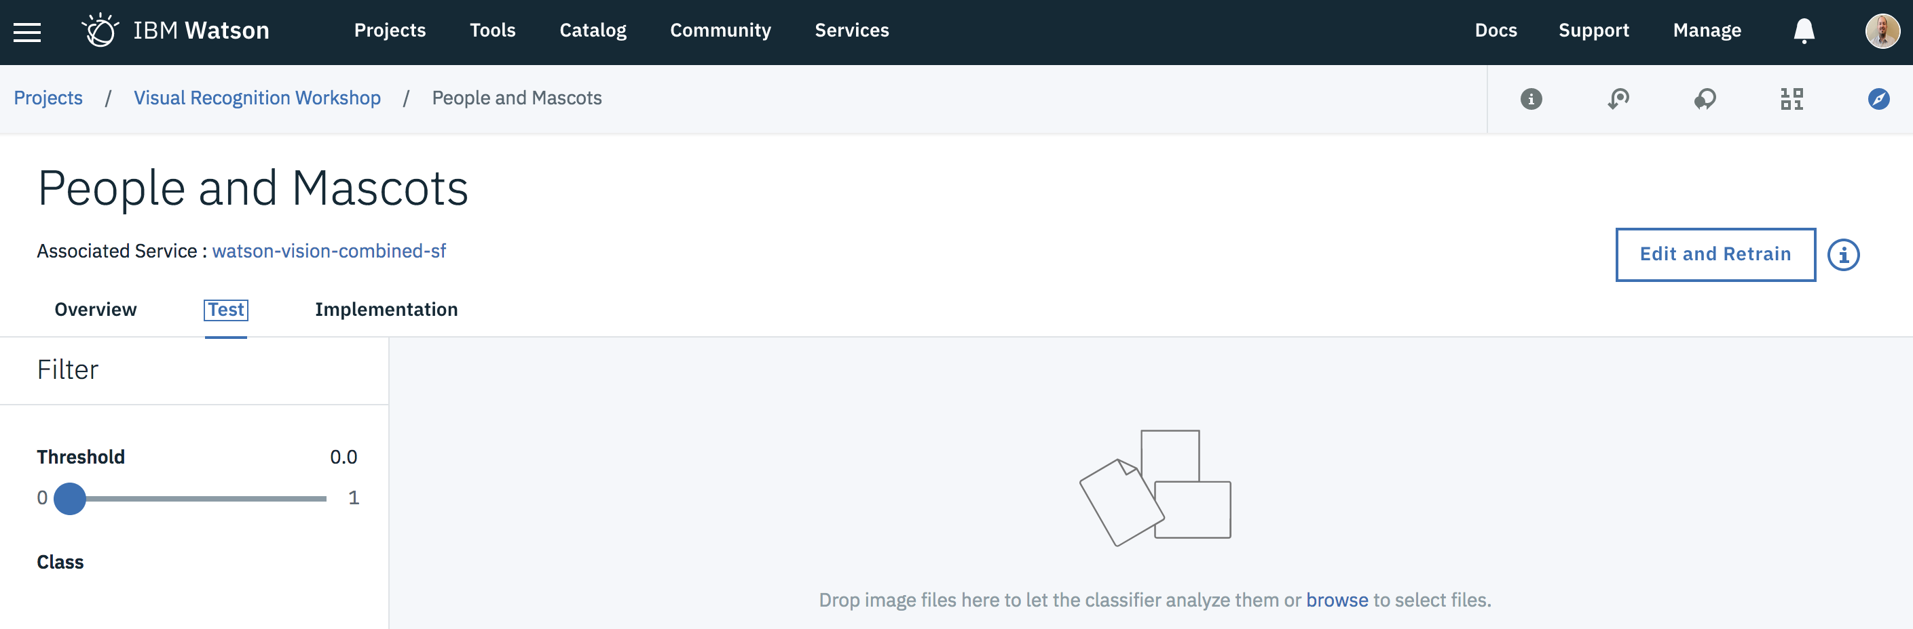

# Part 4: Testing the Model

Drag and drop the first image titled “MascotTest.jpeg”.

What are the results? ________________________

Drag and drop the second image titled “HumanTest.jpeg”.

What are the results? ________________________

Now for the third image titles “OtherTest.jpeg”.

What are the results? ________________________

What do these numbers mean? ________________________________________________

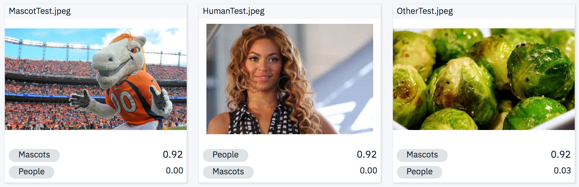

Both the mascot and human have over 50% confidence rating for what the tool believes they are based on our small training set. However, look at the alternative option; the tool is very confidence that it is not the alternate option.

Why did the sprouts show up as a Mascot? ___________________________________________

Let’s look at the other classifiers given to us to test to compare accuracy.

Go back to IBM Cloud using <https://console.bluemix.net> and click on your Watson Visual Recognition Service. Click “Launch tool”.



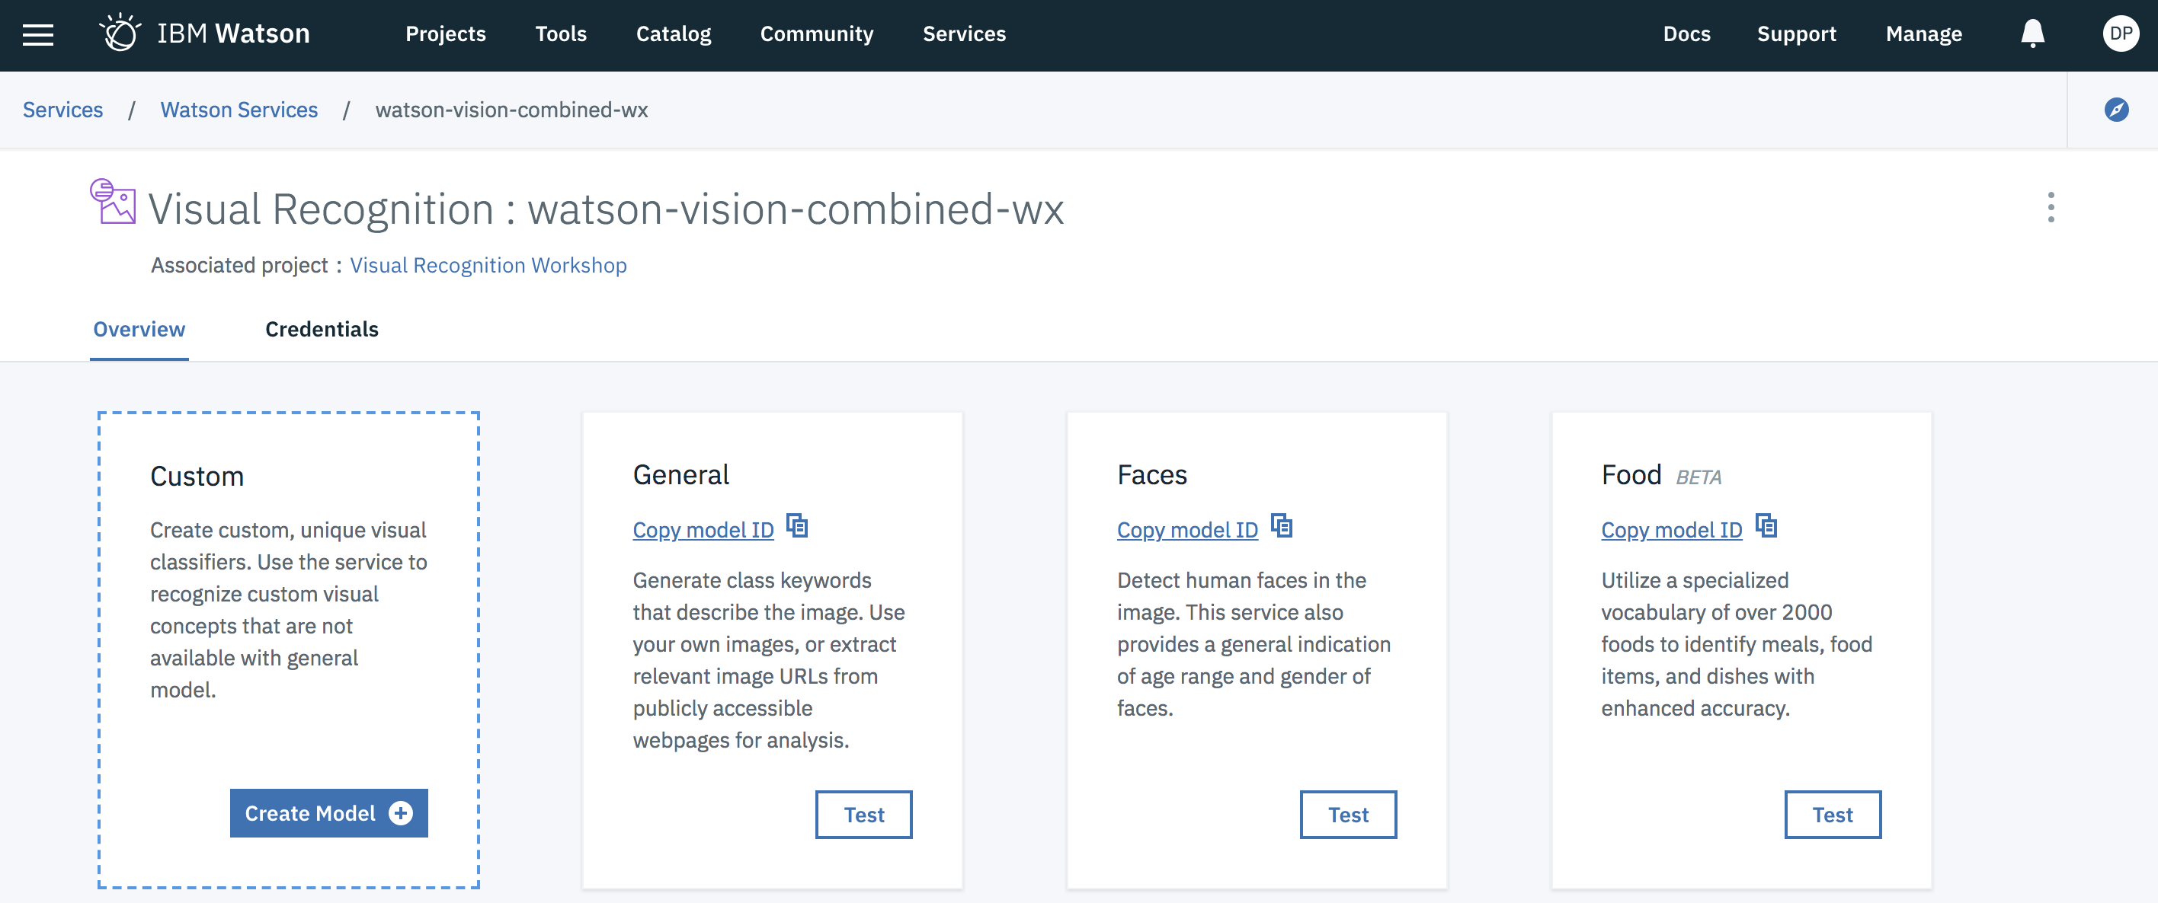

Click “Test” on each of the other classifiers you wish to try. The delivered classifiers are pre-trained by IBM. When you click on each one, click “Test” on the page that opens and drag the file you wish to test with onto the page.

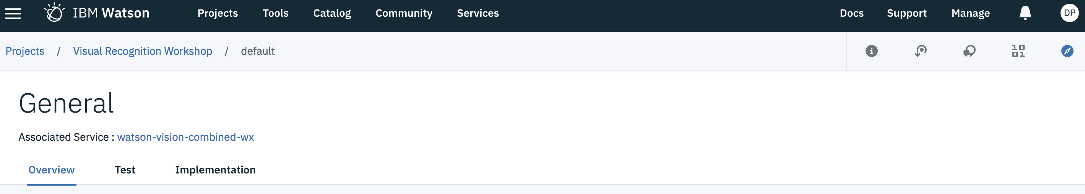

For example, drag and drop “MascotTest.jpeg” into the General classifier.

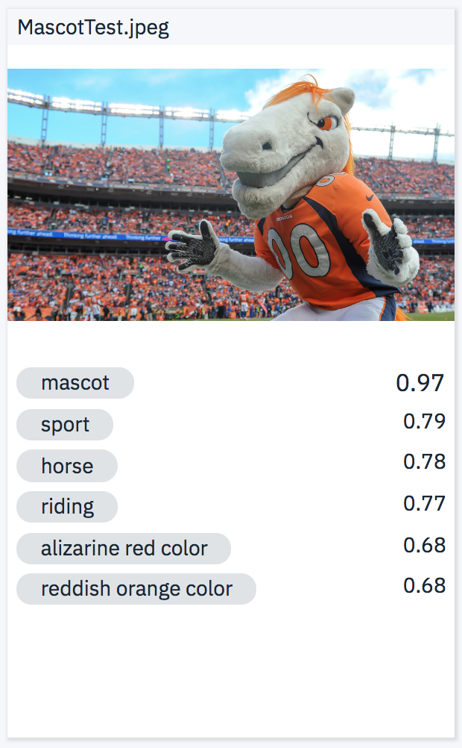

Drag and drop “HumanTest.jpeg” into the face detection classifier.

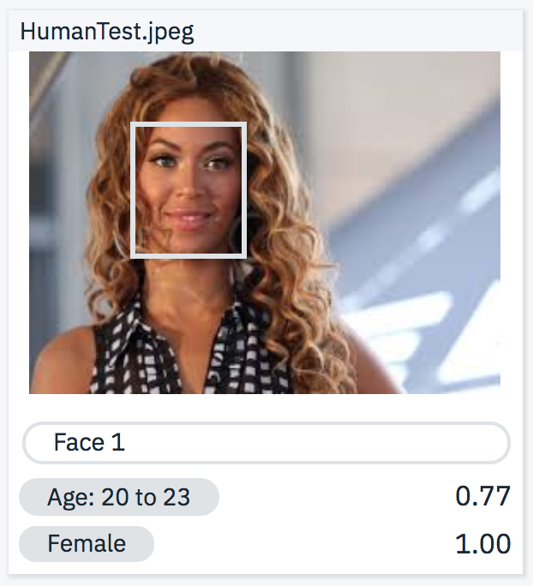

Lastly, drag and drop “OtherTest.jpeg” into the food classifier.

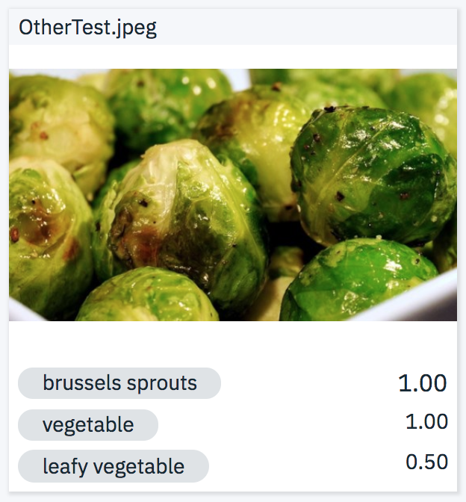

Why are these classifiers much more accurate? __________________________________

# Conclusion

Next steps would include integrating the Watson Visual Recognition service with other services and applications. Some background can be found at the following site.

<https://console.bluemix.net/docs/services/visual-recognition/getting-started.html#getting-started-tutorial>

Now that you have completed this lab, you should be able to

* Navigate IBM Cloud Platform
* Launch Services from IBM Cloud
* Use Watson Visual Recognition (including training a models)